

American International University-Bangladesh (AIUB)  
**Department of Computer Science  
Faculty of Science & Technology (FST)**

**EduARscape –** **an Augmented Reality Enhanced Learning Platform**

A Software Requirement Engineering Project Submitted

By

|  |  |  |  |  |
| --- | --- | --- | --- | --- |
| **Semester: Fall_24_25** | | **Section: D** | **Group Number: 03** | |
| SN | Student Name | Student ID | Contribution in % (100) | Individual Marks |
| 2 | |  |  | | --- | --- | |  | | | AHMED, MIR SHOAIB |  | | | 19-41772-3 | 100 |  |
| 30 | HIMEL, FAISHAL UDDIN | 22-45996-1 | 100 |  |
| 31 | HASIB, MD. TAHSIN | 22-46026-1 | 100 |  |
| 36 | OPU, ASHRAFUL ISLAM | 22-47433-2 | 100 |  |

The project will be Evaluated for the following Course Outcomes

|  |  |  |
| --- | --- | --- |
| **EVALUATION CRITERIA** | Total Marks (50) | |
|  | |
| Introduction [Section 1.1-1.4], Format, Submission, Defense | [10 Marks] |  |
| System Overall Description & Functional Requirements | [10 Marks] |  |
| System Quality Attributes and Project Requirements | [10 Marks] |  |
| UML and E-R Diagram with Data Dictionary | [10 Marks] |  |
| UI/UX Prototyping | [10 Marks] |  |

Software Requirements Specification

for

EduARscape – an Augmented Reality Enhanced Learning Platform

Version 7.0 approved

Prepared by

Md. Tahsin Hasib, Faishal Uddin Himel, Ashraful Islam Opu, Mir Shoaib Ahmed

American International University - Bangladesh

15 January 2025

Table of Contents

Revision History 4

1. Introduction 4

1.1 Purpose 4

1.2 Document Conventions 5

1.3 Intended Audience and Reading Suggestions 5

1.4 References 6

2. Overall Description 6

2.1 Product Perspective 6

2.2 Product Functions 7

2.3 User Classes and Characteristics 8

2.4 Hardware and Operating Environment 10

2.5 Design and Implementation Constraints 10

2.6 User Documentation 11

3. System Requirements 12

3.1 System Features 12

3.1.1 Device Login 12

3.1.2 Institutional Signup 13

2.1. The system shall provide a signup form for Institutions in the Admin control panel. 13

3.1.3 Student Signup 13

3.1.4 Forgot Password 14

3.1.5 Guest User Mode 14

3.1.6 Simulate Virtual Environment 14

3.1.7 Content Creation 15

3.1.8 Holographic Communication 15

3.1.9 Detect visualizable equations on the fly 15

3.1.10 Time based learning modules 16

3.1.11 AR field trips for every user 16

3.1.12 Assesment Preparation 16

3.1.13 Assesment Distribution 16

3.1.14 Live Streaming 17

3.1.15 Student Monitoring for Teachers 17

3.1.16 Natural Language Interface 17

3.2 Non-Functional/Quality Requirements 18

3.3 Project Requirements 19

4. Design and Interface Requirements 20

4.1 UML Diagrams 20

4.2 Data Dictionary 25

4.3 UI/UX Design Specification 27

# Revision History

|  |  |  |  |
| --- | --- | --- | --- |
| **Name** | **Date** | **Reason for Changes** | **Version** |
| Tahsin | 1.1.2025 | Product perspective was not according to the convention | 1.0 |
| Tahsin | 4.1.2025 | The operating environment was for windows based softwares only | 2.0 |
| Himel & Opu | 5.1.2025 | Updated Functional & Non-Functional Requirements | 3.0 |
| Tahsin | 8.1.2025 | Included performance and scalability attributes | 4.0 |
| Tahsin | 12.1.2025 | Reviewed and corrected formatting inconsistencies | 5.0 |
| Tahsin | 14.1.2025 | Updated E-R diagrams | 6.0 |
| All | 15.1.2025 | Final review and version approval | 7.0 |

# Introduction

## Purpose

This document specifies the software requirements for **EduARscape**. It serves as a comprehensive guide to the features and functionalities of the product and outlines the requirements needed for its development and deployment. This document applies to **Version 7.0** of the product, which encompasses the core features and capabilities of the product. The product is a self-contained educational system comprising AR-enabled hardware (such as [Apple Vision Pro](https://www.apple.com/apple-vision-pro/) headsets) and a companion desktop application for content management. This document also highlights the challenges faced by traditional educational institutions, particularly in developing countries, where insufficient laboratory facilities often impede students' ability to comprehend practical concepts in disciplines such as science, technology, engineering, and mathematics (STEM). This product aims to address these issues by enabling virtual simulations of practical experiments and complex [STEM](https://www.education.wa.edu.au/what-is-stem#:~:text=STEM%20is%20an%20approach%20to,creativity) concepts which enhance practical learning experience and bridge the gap in resource availability along with increasing student engagement and support educational institutions in adopting innovative teaching methodologies.

## Document Conventions

This document follows standard formatting and typographical conventions:

* The document follows a **consistent** **numbering** system for all **sections** and **subsections**.
* **Bold Text:** Used for section **headings**, **subsection** **titles**, and **key terms** to enhance readability.
* **Italic Text**: Used for emphasizing specific terms, defining new terminology, or elaborating on features and properties in detail.
* **Requirement Categorization**: Requirements are classified into two main categories:
  + **Functional Requirements (FR)**: Represent core functionalities of the product, identified using the format **FR-[ID]** (e.g., **FR-01**).
  + **Non-Functional Requirements (QAN)**: Specify performance, usability, reliability, and other quality attributes, identified using the format **QA[N]** (e.g., **QA1**).
* Priority levels are indicated using **red** **color texts** such as High, Medium, and Low.
* Rationales for specific priority levels are indicated with **blue texts** to explain the reasoning behind the assigned priority and some examples provided for clarification are denoted using **black texts**.
* Certain text highlighted in blue also contains embedded hyperlinks for quick access to additional resources or references.
* Unordered lists are used throughout this document to present related items or key points in a non-sequential manner. The following conventions are used for unordered lists:
  + **Bullet Style**: Standard bullet points are used to denote items of equal importance.
  + **Indentation**: Nested bullet points indicate sub-items or details related to the primary item.
* Superscripts are used in this document to indicate exponents, derivatives, or other notations that require a raised symbol in mathematical formulas (E.g. Calculating COCOMO).

## Intended Audience and Reading Suggestions

This document is intended for a diverse group of stakeholders involved in the development, deployment, and maintenance of the product. Each type of reader can refer to specific sections that are most relevant to their role. It is recommended that all readers begin with the **Introduction** section to understand the context and purpose of the product. Developers, project managers, and testers should then proceed to the **Requirements** section for detailed specifications. Documentation writers and marketing staff may benefit from reviewing the System Overview and **Features** sections to gain a broad understanding of the product’s functionality. End users may skip technical details and focus on the user-centric sections such as User Interface and Usage Scenarios.

## References

[1] **NeuroSYS Blog: Generative AI in Learning and Education**  
*Author:* NeuroSYS  
*Date Accessed:* 18 December 2024  
*URL:* <https://neurosys.com/blog/generative-ai-in-learning-and-education>

[2] **Apple Vision Pro Product Page**  
*Source:* Apple Inc.  
*Date Accessed:* 18 December 2024  
*URL:* <https://www.apple.com/apple-vision-pro/>

[3] **Microsoft Learn: Windows Mixed Reality Minimum PC Hardware Compatibility Guidelines**  
*Author:* Microsoft  
*Date Accessed:* 4 January 2025  
*URL:* <https://learn.microsoft.com/en-us/windows/mixed-reality/enthusiast-guide/windows-mixed-reality-minimum-pc-hardware-compatibility-guidelines>

[4] **ARKit (Augmented Reality)**  
Author: Apple  
Date Accessed: 15 January 2025  
URL: <https://developer.apple.com/augmented-reality/arkit/>

# Overall Description

## Product Perspective

In recent years, Augmented Reality (AR) has gained significant attention as an innovative tool in education, enhancing learning experiences through interactive, immersive environments. Traditional educational institutions, especially in developing countries, often lack adequate laboratory facilities, which hinders students' ability to grasp practical concepts in fields like science, technology, engineering, and mathematics (STEM). Students often receive knowledge as a passive learning paradigm such as teachers or textbooks. Many educational concepts are taught in an abstract form without meaningful connections to the real world which hinders their ability to apply it in real world situations and limits their ability to remember it. This gap in resources negatively impacts the quality of education and limits students' willingness for advanced studies or professional careers.

This product described in this Software Requirements Specification (SRS) is a **new**, **self-contained** **educational device** which aims to bridge this gap by providing virtual laboratory, field trips and interacting with virtual objects in real-time experiences through **augmented reality (AR) and 3D visualization**. This solution integrates both hardware and software to deliver AR-based educational content. The software component will run on AR-enabled devices, while the hardware will include specialized AR headsets or glasses, ensuring a seamless and immersive user experience. This product is not a direct follow-on or replacement for any existing product but is an innovative solution tailored for educational institutions.

The primary business objective of this AR-based educational system is to provide an innovative solution that enhances the quality of STEM education, particularly in institutions facing resource constraints. The business goals are:

1. Enable students to better understand and retain complex STEM concepts through hands-on AR simulations and visualizations.
2. Bridge the gap for institutions lacking modern lab facilities by providing a cost-effective and scalable alternative.
3. Encourage a dynamic, captivating learning atmosphere that accommodates a range of learning preferences and styles.
4. Provide teachers, content creators with tools to create and deliver dynamic AR content, making it easier to explain complex topics.
5. Target educational institutions in both developed and developing regions and make the company a pioneer in educational technology by promoting the use of AR in practical education.
6. Create a sustainable business model by offering the product as a subscription-based service or one-time purchase, with potential for additional revenue through content licensing and custom development.

## Product Functions

This product is an **Augmented Reality (AR)** based designed to transform education by offering immersive, interactive, and personalized learning experiences. The high-level summary of the product includes:

**3D Visualization and Analysis:**

* Render complex mathematical problems such as graphs, simulation and 3D visuals for real-time analysis.
* Enable immersive interaction with complex data sets, including zooming, rotating, and slicing 3D models.
* Support multi-user interaction in the same 3D environment for group activities.

**Content Creation and Delivery:**

* Enable teachers to create or request engaging spatial content.
* Offer a content library with ready-to-use AR/VR modules for various subjects.
* Support multi-format content delivery (2D, 3D, interactive AR).
* Provide tools for content creators to develop custom materials for educational use.
* Enable real-time updates and cloud-based distribution of new learning materials.

**Holographic Communication:**

* Support directional speech for communication within a holographic environment
* Allow for virtual avatars and hand gestures to enhance communication in real-time.

**Geo-Fencing and Location-Aware Features:**

* Use GPS to enable geo-fencing for virtual environment control.
* Enable location-specific AR content to enhance outdoor or field learning activities.

A Context-Level-Data-Flow Diagram is given below:

**Fig: Context-Level-Data-Flow-Diagram**

## User Classes and Characteristics

Various user classes and their difference:

|  |  |  |  |  |  |
| --- | --- | --- | --- | --- | --- |
| **Type** | **Frequency of use** | **Subset of product functions** | **Technical Expertise** | **Privilege Level** | **Experience** |
| **Students**  Most Important | High  (daily or frequent usage during class sessions and independent study) | Access to interactive AR content, participation in AR-based activities, and engagement with 3D visualizations. | Moderate  (basic familiarity with modern educational tools and devices) | Low  (restricted access, limited to viewing and interacting with content) | Primary, secondary and higher education students |
| **Teachers**  Most Important | High  (daily use for instructional purposes) | Content creation, lesson planning, AR session control, and student progress tracking. | Moderate  (general understanding of educational technology with training) | Medium  (Create, Modify, Manage Content) | Formal training in STEM subjects or relevant teaching experience. |
| **Administrator**  Important | Moderate  (Occasional use for system setup, maintenance, and monitoring) | System configuration, user account management, and performance analytics.  System configuration, user account management, and performance analytics. | High  (Handle system-level tasks, Troubleshoot issues) | High  (Full control over system settings) | IT professionals or technical staff with a background in system administration |
| **Content Creator**  Important | Moderate  (Periodic updates and content creation) | Advanced AR content creation, integration of new learning modules, and updates to existing materials | High  (AR development, 3D modeling, and instructional design) | Medium to high  (content creation but not system-level control) | Professionals with backgrounds in instructional design, AR development, or multimedia creation |
| **Guest**  Less Important | Low  (No ability to modify or create new content.) | Limited access to AR based field trips | Moderate | Low | Primary, secondary and higher education students or any |

**Characteristics of Each User Class:**

**Students:** Students will primarily use the system to visualize complex STEM concepts, interact with augmented models, and participate in immersive learning sessions.

**Teachers:** Teachers will use the product to design interactive lessons, manage AR experiences during classes, and guide students through complex subjects. They will need intuitive tools for content management and lesson customization to accommodate different teaching styles and objectives.

**Admin:** Administrators will focus on backend operations, ensuring data security, maintaining user roles, and overseeing the overall deployment and integration of the system.

**Guest:** Guest users will have limited access to the system, allowing them to join AR-based labs for virtual field trips and explore specific educational content without needing a permanent account. This feature will enable institutions to showcase AR-driven learning experiences to external participants or visiting groups.

## Hardware and Operating Environment

The hardware platform includes AR headsets (such as [Microsoft HoloLens](https://learn.microsoft.com/en-us/hololens/hololens2-setup) or [Apple Vision Pro](https://www.apple.com/apple-vision-pro/)). These wearable AR goggles will enable students to simulate and interact with virtual content in real-time, providing a hands-on, engaging learning environment. The software integrated into these devices will be complemented by a companion desktop application designed to handle heavy simulations and rendering-intensive tasks. This approach ensures that resource-intensive computations are offloaded into more powerful hardware, enabling smoother performance on the AR devices. The AR device will operate using a customized operating system optimized for augmented reality applications. This OS will be based on a lightweight Linux kernel, IOS or a specialized version of [Windows Mixed Reality](https://learn.microsoft.com/en-us/windows/mixed-reality/enthusiast-guide/windows-mixed-reality-minimum-pc-hardware-compatibility-guidelines) (Windows 10, version 20H2 through Windows 11, version 23H2). Additionally, tablets and smartphones with AR capabilities (including iPads and Android devices) will serve as supplementary tools, offering a more accessible option for institutions that may not have widespread access to AR headsets. The system will utilize advanced AR development frameworks such as [Unity 3D](https://unity.com/) with AR Foundation, [ARKit](https://developer.apple.com/augmented-reality/arkit/) for iOS devices, and ARCore for Android devices to ensure a seamless and immersive user experience. Additional software requirements include seamless integration with existing Learning Management Systems (LMS) through APIs, cloud storage solutions for synchronizing content and updates, and a web-based dashboard to facilitate content and user management for educators and administrators. Stable internet connectivity is necessary for real-time updates and synchronization, but the system will also support offline access to pre-downloaded AR content, ensuring functionality in environments with limited internet availability.

## Design and Implementation Constraints

The following constraints are applied while designing and implementing the software:

|  |  |  |
| --- | --- | --- |
| **Hardware & Operating System Constraint (minimum requirements)** | | |
| **Specs** | **Windows** | **IOS** |
| **Processor** | * Intel Core i5 4590 (4th generation), quad-core (or better) * AMD Ryzen 5 1400 3.4Ghz (desktop), quad-core (or better) | * *Apple A12 Bionic (or later)* * *Apple M1 or M2 chip for iPads and Macs* |
| **RAM** | * 8 GB DDR3 (or better) | * 4 GB (iPads and iPhones) or 8 GB (Macs) |
| **Free disk space** | * At least 10 GB | * At least 10 GB of available storage |
| **Graphics Card** | * NVIDIA GTX 1060 (or greater) DX12-capable discrete GPU * AMD RX 470/570 (or greater) DX12-capable discrete GPU * Must support GPU acceleration | * Apple GPU (Metal-capable) |
| **Graphics Driver** | * Windows Display Driver Model (WDDM) 2.2 | * Apple Driver |
| **Bluetooth connectivity** | * Bluetooth 4.0 | * Bluetooth 5.0 (or later) |
| **OS** | * Windows 10, 11 * Compatible with Windows Mixed Reality for HoloLens devices. | * IOS 15 * Compatible with visionOS for Apple Vision Pro |
| **Tools & Framework** | * *Requires Unity, Visual Studio, and Windows Mixed Reality APIs.* * Use of cross-platform AR frameworks, such as Unity AR Foundation | * Requires Xcode, SwiftUI, RealityKit, and ARKit. * Unity AR Foundation |
| **Integration** | | |
| **Integration** | * *Seamless integration with existing Learning Management Systems (LMS) through RESTful APIs and cloud services is mandatory.* * Must support cloud-based synchronization of AR content, with offline functionality for environments with limited internet connectivity. | |
| **Security** | | |
| **Security** | * *User data, including progress and personal information, must be encrypted both in transit and at rest.* * *Must comply with privacy regulations, such as GDPR, to ensure data protection and user privacy.* * Role-based access control (RBAC) must be implemented to distinguish between different user classes (students, educators, and administrators). | |
| **Programming Standard** | | |
| **Programming Standard** | * *Must adhere to industry best practices and coding standards for maintainability and scalability* * *Continuous Integration/Continuous Deployment (CI/CD) pipelines should be established to ensure rapid and reliable updates.* | |
| **Design Convention** | | |
| **Design Convention** | * *Should support accessibility features, including eye-tracking, voice commands, and gesture controls, to enhance usability for a diverse range of users.* * *Modern design principles for AR environments, ensuring intuitive navigation and interaction.* | |
| **Performance** | | |
| **Performance** | * *The system should maintain low latency (less than 50 milliseconds) for AR interactions to provide a smooth and responsive user experience.* * Heavy simulations should be processed on companion desktop applications to minimize performance bottlenecks on the AR devices. | |

## User Documentation

The following user documentation components will be delivered along with the software:

* A user manual covering installation, initial setup, and usage of both the AR device and the companion desktop application.
* A set of interactive tutorials designed to help new users quickly become familiar with the AR platform which will cover basic navigation, interacting with virtual content, and advanced features such as creating custom simulations.
* Embedded help system within the AR and desktop applications, offering immediate assistance without requiring users to leave the application environment.

# System Requirements

## System Features

The **Requirements Prioritization Matrix** presented below evaluates each functional requirement based on key factors such as **Relative Benefit**, **Relative Penalty**, **Relative Cost**, and **Relative Risk**. This structured approach helps determine the overall priority of each requirement, ensuring that critical features are identified and addressed with higher urgency. Priority levels are calculated by considering the weighted contributions of each factor, resulting in a clear ranking of requirements.

**Fig: Requirements Prioritization Matrix**

A full sheet containing the prioritization matrix available here: <https://docs.google.com/spreadsheets/d/1L4REU-zQi7F9NmiRq1pGaqZDj8PwutOxYD0pw7euXFc/edit?usp=sharing>

### Device Login

**Functional Requirements (FRs)**

* 1. The device shall allow users to login with their given username and password.
  2. The credentials will be matched against the system database.
  3. If the credentials match the database, the login will be successful, and users will be taken to the home screen.
  4. If the credentials do not match, then users will be notified about the wrong credentials and will be given 3 chances for the login attempt.
  5. If a user attempts more than 3 times with wrong credentials the device will be locked for 10 minutes. A countdown timer will be shown to the user for next tries.
  6. If the user has 2 Factor Authentication enabled, then an OTP code will be sent to the user’s email address or phone number (whichever is setup before).
  7. If an OTP code was sent, upon login the system will ask for the OTP code for successful login.

**Priority Level:** High

**Precondition:** The device must be registered with the system and users shall have valid credentials.

**Cross-references:** N/A

### Institutional Signup

**Functional Requirements (FRs)**

## The system shall provide a signup form for Institutions in the Admin control panel.

* 1. Admin should fill up the sign-up form with appropriate information from the paperwork.
  2. Institutions should provide their unique EIIN number to sign up.
  3. Institutions should provide their required number of devices.
  4. The system shall generate a unique ID for each of the student’s account and a one-time password which will be handed over to the students, which they have to change after their first login.
  5. Admin will hand over the Institution account dashboard to the designated Teachers from the Institution upon a successful sign up.

**Priority Level:** High

**Precondition:** Institutions must provide their official documents including paperwork from Government issued documents.

**Cross-references:** N/A

### Student Signup

**Functional Requirements (FRs)**

* 1. Teachers should collect the emails of their students to assign device accounts to them.
  2. Teachers should also assign additional information such as their Name, Semester, Taken courses.
  3. Teachers should set a timeframe for validity of the student’s account.

**Priority Level:** High

**Precondition:** Teachers should have access to an institutional account all the student’s email to

sign up accounts for them.

**Cross-references:** N/A

### Forgot Password

**Functional Requirements (FRs)**

* 1. The system shall provide a “Forgot Password” option in the login interface.
  2. Users should be able to provide their unique ID to identify their account in order to create a new password.
  3. The system shall send a Password reset link to the user’s email.
  4. The system should check if the account has 2 factor authentication enabled and ask for the OTP code in that case.
  5. The system should check that the new password does not match any old password.

**Priority Level:** High

**Precondition:** The account must exist on the system.

**Cross-references:** N/A

### Guest User Mode

**Functional Requirements (FRs)**

* 1. The system should provide a limited access account for the Guest user.
  2. The Guest user account should be able to join AR Trips without logging in.
  3. The system should do a check for the account type before the Guest user joins the AR Trips and limits collaborative access.
  4. Access limitations for guest users shall be clearly communicated by the system through notification.

**Priority Level:** Medium

**Precondition:** N/A

**Cross-references:** N/A

### Simulate Virtual Environment

**Functional Requirements (FRs)**

* 1. The system shall allow students to simulate live generative experiments with the help of AR.
  2. Upon choosing the option, students can generate data based on the lab experiment and save for later use.
  3. Teachers will be able to evaluate students on the virtual lab based on their simulated performance.

**Priority Level:** High

**Precondition:** The students should be allowed first to enter virtual environment by

respective teachers.

**Cross-references:** N/A

### Content Creation

**Functional Requirements (FRs)**

* 1. The system should facilitate a hub for content creators to see available works for them.
  2. The teachers should be able to place requests for making new content to the content creators.
  3. The system should provide a space for content creators to upload their contents.

**Priority Level:** High

**Precondition:** Content creators should be logged in.

**Cross-references:** N/A

### Holographic Communication

**Functional Requirements (FRs)**

* 1. The system should provide a communication method between teachers and students while using the AR device.
  2. The holographic communication method should show an avatar of both the parties communicating.
  3. The communication method should work in a directive way such that when a user looks in the direction of someone, they can initiate a conversation.

**Priority Level:** High

**Precondition:** The system must track the user’s head movement to accurately point to other

users in the holograph.

**Cross-references:** N/A

### Detect visualizable equations on the fly

**Functional Requirements (FRs)**

* 1. The system shall analyze text inputs to identify mathematical equations.
  2. After identifying the mathematical equations, the students will be provided options to visualize the equations.
  3. Upon choosing the option, the student would be able see the graphical representation of the mathematical equations.

**Priority Level:** High

**Precondition:** The system should be able to detect mathematical equations.

**Cross-references:** N/A

### Time based learning modules

**Functional Requirements (FRs)**

* 1. The teacher should provide learning modules related for current semester to the students.
  2. The system shall expire the modules based on semester timespan.
  3. The teacher should be able to revoke access for the learning modules at any time.

**Priority Level:** Medium

**Precondition:** N/A

**Cross-references:** N/A

### AR field trips for every user

**Functional Requirements (FRs)**

* 1. The system would allow the content creators to upload 3D videos covering various educational topics and destinations.
  2. After uploading the 3D videos, the system would allow access to any kind of user.
  3. In the user interface, the system shall offer a selection of AR field trips to the user.
  4. After selecting the options, the users would be able to join the AR field trip.

**Priority Level:** High

**Precondition:** The 3D videos should be available in the system

**Cross-references:** FR-3.1.7

### Assesment Preparation

**Functional Requirements (FRs)**

* 1. The teachers should be able to create new assessments for the students.
  2. Assessment parameters such as time limits and grading criteria shall be customizable by teachers.
  3. The system shall provide analytics tools for analyzing assessment results and tracking student progress.
  4. The teachers should have access to previously set questions from the system.

**Priority Level:** Medium

**Precondition:** The teachers must log into the system.

**Cross-references:** FR-3.1.7

### Assesment Distribution

* 1. Teachers shall have the ability to create and distribute assignments to individual students or groups.
  2. Assignment details such as instructions, due dates, and resources shall be provided within the system by the teacher.
  3. Students shall receive notifications and reminders about assigned tasks.

**Priority Level:** Medium

**Precondition:** N/A

**Cross-references:** N/A

### Live Streaming

**Functional Requirements (FRs)**

* 1. The system should provide a live class session for the students.
  2. After starting the live session the students would be able to join the session.
  3. Before joining the live session the teacher should give permission to each students.
  4. Live streams shall support real-time interaction with students, including chat and Q&A features.

**Priority Level:** Medium

**Precondition:** The teacher must have a valid and active user account on the streaming

Platform.

**Cross-references:** N/A

### Student Monitoring for Teachers

**Functional Requirements (FRs)**

* 1. Teachers should be directed to a comprehensive dashboard after logging in.
  2. The dashboard must display metrics related to student engagement, including Login frequency, Assignment completion status.
  3. Based on the gathered metrics, teachers should have the capability to send notifications to students as needed.

**Priority Level:** High

**Precondition:** The system must incorporate a dashboard for the teacher.

**Cross-references:** N/A

### Natural Language Interface

**Functional Requirements (FRs)**

* 1. The user should be able to control the system using natural language instructions.
  2. The system should support real-time translation of voice input from one language to another, selectable from predefined lists of languages.

**Priority Level:** High

**Precondition:** The system must incorporate a natural language interface with real-time translation capabilities.

**Cross-references:** N/A

## Non-Functional/Quality Requirements

**QA1: Usability:** A user shall be able to launch and navigate the AR application (both on the AR device and the desktop companion) within an average time of 5-7 seconds in a normal operating environment.

**Priority Level:** High **Precondition:** The user must have completed the initial setup and device calibration process.  
**Cross-references: QA4 (Accessibility)**

**QA2: Performance:** The AR device shall render virtual content with a latency of no more than 50 milliseconds to ensure a seamless augmented reality experience.

**Priority Level:** High **Precondition:** The AR headset must be operating within the recommended hardware and network specifications.  
**Cross-references: QA5 (Scalability)**

**QA3: Reliability:** The system shall maintain 99.9% uptime during operational hours, with automatic recovery from minor system failures.

**Priority Level:** Medium **Precondition:** Stable internet connectivity is required for cloud-based synchronization features.  
**Cross-references: QA5 (Security)**

**QA4: Accessibility:** The software shall support interaction through multiple input methods, including voice commands, hand gestures, and eye tracking, ensuring ease of use for users with different abilities.

**Priority Level:** High **Precondition:** The AR device must be properly calibrated to the user’s input preferences during the initial setup. **Cross-references: QA1 (Usability), QA7 (Maintainability)**

**QA5: Scalability:** The system shall support up to 100 simultaneous users connected to a single virtual classroom session without a noticeable degradation in performance.

**Priority Level:** Medium **Precondition:** The hosting server must meet the recommended cloud service specifications for load balancing. **Cross-references: QA2 (Performance), QA3 (Reliability)**

**QA6: Security:** The system shall use encrypted communication protocols (e.g., HTTPS, SSL/TLS) for all data transmissions to and from the cloud.

**Priority Level:** High **Precondition:** Users must log in using a secure authentication mechanism. **Cross-references: QA3 (Reliability), QA5 (Maintainability)**

**QA7: Maintainability:** The system shall allow modular updates, enabling developers to roll out software patches and new features without interrupting ongoing sessions.

**Priority Level:** Medium **Precondition:** A version control system must be in place to manage and deploy updates. **Cross-references: QA5 (Scalability), QA6 (Security)**

**QA8: Compatibility:** The software shall be compatible with visionOS, Windows Mixed Reality, macOS, and Windows desktop platforms.

**Priority Level:** High **Precondition:** Devices and operating systems must be updated to their latest stable versions. **Cross-references: N/A**

## Project Requirements

Let’s assume the Source Line of Code is **6000**

So, Effort needs to be,

**𝑃𝑀 = 2.4 × (6000/1000 )1.05 = 15.75**

Development time,

**𝐷𝑀 = 2.50 × (𝑃𝑀)0.38 = 7.13 ≈ 7**

Required number of people,

**𝑆𝑇 = 𝑃𝑀/𝐷𝑀 = 2.2 ≈ 3**

Therefore, the work needs to be done for (**4 × 7) = 28** weeks

The COCOMO (Constructive Cost Model) is used to estimate the effort, development time, and team size required for this project. Given an assumption of Source Lines of Code (SLOC) of 6000, the effort is calculated as 15.75 person-months using the basic COCOMO formula. The development time is estimated to be 7 months, and the required team size is approximately 3 people. This project is classified under the Organic Mode, which suits small to medium-sized projects with well-understood requirements.

# Design and Interface Requirements

This section presents the core design diagrams that illustrate the proposed solution architecture and user interaction flow. The diagrams provide a detailed visual representation of the system’s structure, behavior, and data relationships, ensuring a clear understanding of how the solution will function.

## UML Diagrams

* + 1. **Use Case Diagram**

Primary interactions between different user roles (e.g., students, teachers, admins, and guest users) and the system, highlighting the key functionalities offered by the solution.

**Fig-4.1.1: Use Case Diagram**

* + 1. **Class Diagram**

Explains the system’s object-oriented structure by defining classes, attributes, methods, and relationships, offering a blueprint for the software’s implementation.

**Fig-4.1.2: Class Diagram**

* + 1. **Activity Diagram**

The dynamic behavior of the system by illustrating the workflows and sequence of activities performed by users, ensuring clarity on process flow and decision points.

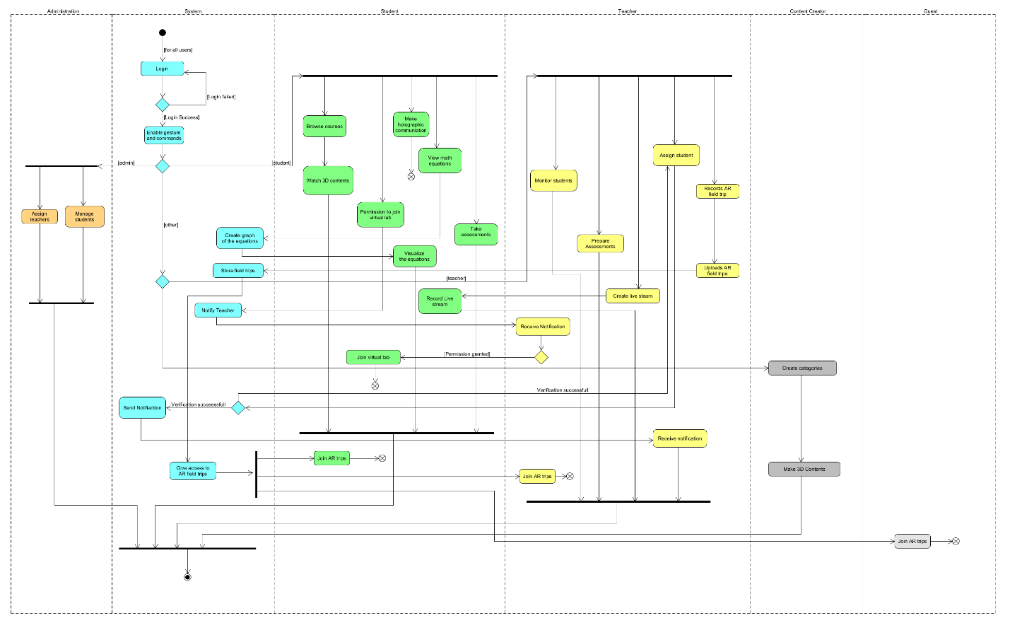

**Fig-4.1.3: Activity Diagram**

* + 1. **ER Diagram**

Models the underlying database structure by defining entities, attributes, and relationships.

**Fig-4.1.4: ER Diagram**

## Data Dictionary

|  |  |  |  |  |
| --- | --- | --- | --- | --- |
| **Entity** | **Attribute** | **Type/Size** | **Validation** | **Key** |
| Student | StudentID | Number (8) | Required, Unique | Primary |
| Username | Text (10) | Required |  |
| Name | Text (30) | Required |  |
| Email | Text (50) | Valid Email Format, Unique |  |
| Password | Text (20) | Required |  |
| EnrolledCourses | Text (100) | Optional |  |
| Teacher | TeacherID | Number (10) | Required, Unique | Primary |
| Username |  | Required |  |
| Name | Text (30) | Required |  |
| Email | Text (50) | Valid Email Format, Unique |  |
| Password | Text (20) | Required |  |
| CoursesAssigned | Text (50) | Required |  |
| Guest | GuestID | Number (15) | Required, Unique | Primary |
| AccessLevel | Text (10) | Must be ‘Limited’ |  |
| Admin | AdminID | Number (8) | Required, Unique | Priimary |
| Username | Text (15) | Required |  |
| Name | Text (30) | Required |  |
| Email | Text (50) | Valid Email Format, Unique |  |
| Password | Text (20) | Required |  |
| Content Creator | CreatorID | Number (12) | Required, Unique | Primary |
| Username | Text (15) | Required, Unique |  |
| Name | Text (30) | Required |  |
| Email | Text (50) | Valid Email Format, Unique |  |
| Password | Text (20) | Required |  |
| CreatedContent | Text (100) | Optional |  |
| AR Content | ContentID | Number (10) | Required, Unique | Primary |
| Title | Text (50) | Required |  |
| Description | Text (200) | Optional |  |
| CreatedBy | Number (12) | Must match existing CreatorID | Foreign Key |
| FilePath | Text (100) | Valid File Path |  |
| CreatedDate | Date | Required |  |
| Location | Text (50) | Optional |  |
| ContentType | Text (20) | Must be ‘Virtual Lab’, ‘3D Model’, or ‘Tutorial’ |  |
| SubjectArea | Text (30) | Example: ‘Physics’, ‘Chemistry’ |  |
| RequiredHardware | Text (50) | |  | | --- | | Example: ‘AR Headset’, ‘Gloves’ |  |  | | --- | |  | |  |
| EstimatedCompletionTime | Number (3) (Minutes) | 1-300 |  |
| Classroom | ClassroomID | Number (6) | Required, Unique |  |
| Capacity | Number (3) | 1-100 |  |
| AssignedTeacherID | Number (10) | Must match existing TeacherID | Foreign Key |
| Device | DeviceID | Number (8) | Required, Unique | Primary |
| DeviceType | Text (20) | Must be ‘AR Headset’ or ‘Desktop’ |  |
| OperatingSystem | Text (15) | Must be ‘visionOS’ or ‘Windows’ |  |
| Status | Text (10) | Must be ‘Active’ or ‘Inactive’ |  |
| AssignedTo | Number (8) | Must match existing UserID | Foreign Key |

## UI/UX Design Specification

This section provides an overview of the user interface (UI) design of the system. The prototype was developed using **Draw.io**, showcasing the key screens, layout, and user interactions for various roles, including students, teachers, admins, and guest users.

**Fig-4.3.1: Sign In, Forget Password Features**

**Fig-4.3.2: Dashboard (Student, Teacher, Guest)**

**Fig-4.3.3: Institutional Signup**

**Fig-4.3.4: AR Field Trips via student and guest dashboard**

**Fig-4.3.5: Equation visualization**

**Fig-4.3.6: Virtual Lab (Student, Teacher)**

**Fig-4.3.7: Learning Modules (Teacher’s)**

**Fig-4.3.8: Creating Learning Modules (Teacher’s)**

**Fig-4.3.9: Natural Language Interface (All)**

**Fig-4.3.10: Student Monitoring (Teacher)**

**Fig-4.3.11: Holographic Communication between users (All)**

**Fig-4.3.12: Assessment Creation (Teacher)**

**Fig-4.3.13: Grades (Teacher)**

**Fig-4.3.14: Live Streaming (Teacher)**

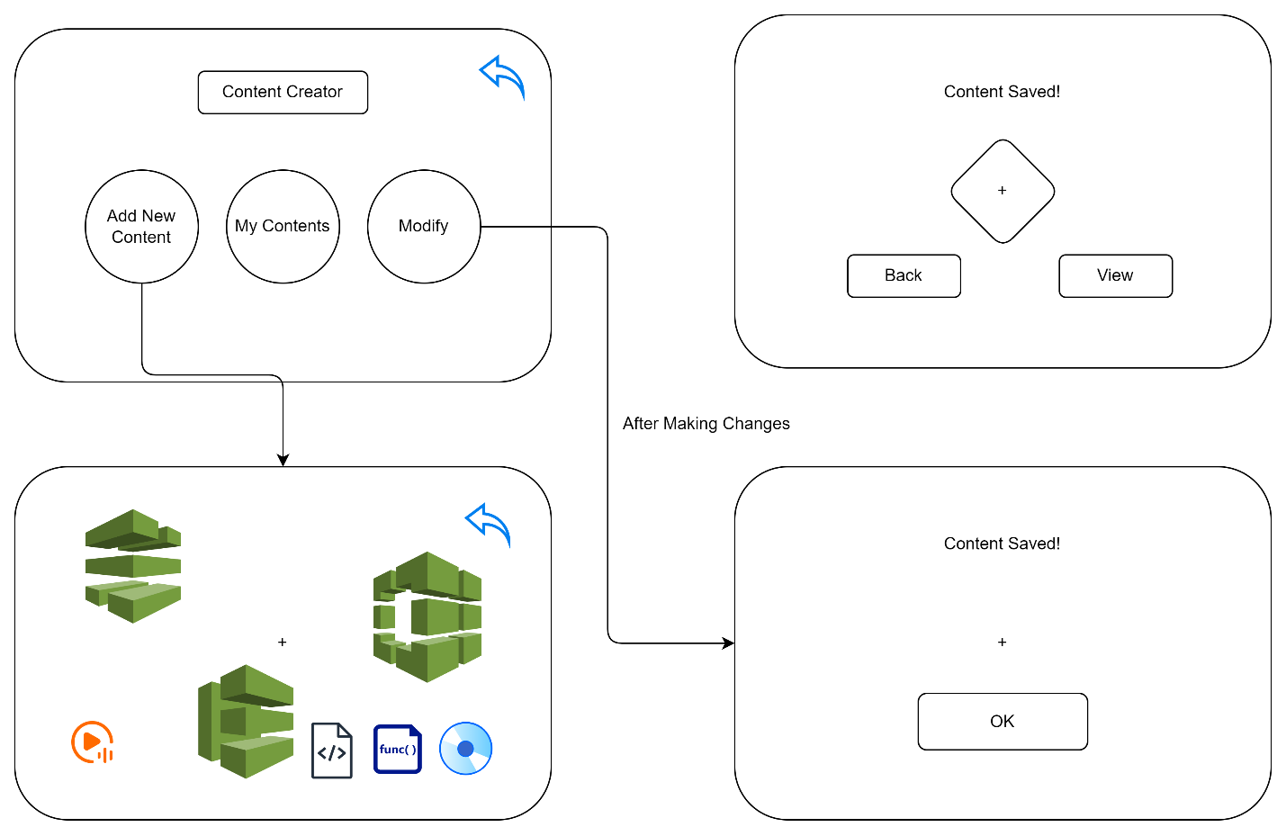

**Fig-4.3.15: Content Creation**

**THE END**